Alora Website Copy - Draft for Team Review

1. Hero
Headline
- Better supply-chain decisions, from BOM to bottom line.
- Where supply-chain risk turns into actions
- Give Your Supply Chain the Power to See Risks Early and Act the Same Day
- Where every supply-chain event becomes clear, ranked, and actionable.

Subheading
- For complex hardware manufacturers, Alora uses AI to connect BOM, parts, and suppliers to builds and customers — starting with a risk-based worklist for procurement and planning, and evolving into a decision layer for the entire supply chain.
- See your BOM insights across your workflows - analyzing risks per each item..
- Ingest BOMs, POs, and supplier updates, keep them continuously in sync, and map every part to its builds and customers.
Upgrade to a platform that turns part-level risk into decisions across your entire supply chain.
- Ingest BOMs, POs, and supplier updates, keep them continuously in sync, and map every part to its builds and customers.
Upgrade to a platform that turns part-level risk into confident supply-chain decisions.
- Pull BOM, ERP, and email signals into one live model of your parts, suppliers, and builds.
Upgrade to a platform that gives every team the same, trusted view of supply-chain risk and impact.
- Alora captures supplier updates and system signals, calculates risk, and delivers a prioritized action plan that keeps your supply chain moving.
- Every change triggers impact. Alora captures it, measures it, ranks it, and drives the next move. Your supply chain becomes actionable.
- Catch SC risks across platforms, analyze real-time effects on your workflows and BOMs, mitigate to keep production on track and revenue secured. Upgrade to the way supply chain was meant to be managed.
- Ingest all your data, store it indefinitely on your cloud, and query across all types with a unified syntax. Upgrade to a platform that extends observability beyond engineering.
- Catch supply-chain risks, see their impact on BOMs and builds, and act before they hit production and revenue. Upgrade to predictive supply chain management.

Primary CTA
Book a demo

Secondary CTA
Request a pilot

2. What Alora does today
Section title
What Alora does today

Text
We start where part-level decisions matter most: procurement and planning.

Alora:
- Connects BOM, parts, suppliers, PO lines, builds, and customers
- Highlights which parts put upcoming builds and deliveries at risk
- Shows which customers and how much revenue are exposed when parts move
- Gives buyers and planners one shared, risk-based worklist of lines and builds to act on

In one sentence:
Alora gives buyers and planners one AI-driven, risk-based worklist of BOM parts and PO lines to act on, with the builds, customers, and revenue they affect.

For leadership, Alora rolls this into a simple view of:
- Which builds and customers are at risk
- How much is on the line
- Who owns the follow-up

3. Pain / Problem
Section title
The daily gap between data and decisions

Even with ERP, reports, and spreadsheets, procurement and planning teams still struggle to answer basic questions at the start of the day:
- Which lines should we focus on first?
- Can we really build this order on time?
- Which customers are at risk if certain parts slip?
Data is spread across ERP, Excel, and email, and deep, multi-level BOMs make it hard to see which specific part really blocks a build.
The result:
- Hours spent reconciling updates instead of acting
- Supply-chain leadership discovering risk when a build is already at risk of delay
- Finance feeling the impact only when it reaches revenue and margin

Alora closes this gap: turning part-level complexity into clear, business-aware decisions.

4. Who we’re built for
Section title
Who we’re built for

Alora is designed for complex hardware manufacturers where a single part can stop a build and BOMs are too deep to manage in spreadsheets.

Industries
- Medical devices
- Robotics
- Defense
- Industrial equipment and other multi-discipline hardware

Company profile
- Multi-level BOMs and sub-assemblies
- Many suppliers and long lead times
- ERP in place (e.g., SAP, Priority)
- Real-life risk still tracked in Excel and email

5. KPI / Impact
Section title
Impact Alora is built to deliver

This can be framed as “What teams aim to achieve with Alora” or “Target outcomes with Alora.”

- 10× Faster – Decision making
From weekly spreadsheet reviews to same-day, risk-based worklists.

- 5% Reduction – Revenue risk
Identify and mitigate part-level risk before it delays builds and shipments.

- 50% Less – Manual work
Automated follow-ups, confirmations, and discrepancy tracking instead of inbox chasing.

- 80% Fewer – Blocked or surprise POs
Early alerts on confirmation gaps, date slips, and mismatched lines across BOM and PO.

6. Vision
Section title
Our vision: from BOM and part-level risk to business outcome

In complex hardware, everything starts with a BOM and a part number — and the risk attached to it.

Alora is building a decision layer on top of the BOM that connects each part, supplier, and BOM position to:
- Part-level risk
- Build readiness
- Revenue and margin impact

Over time, this BOM-driven, risk-aware view will support wider decisions in:
- Sourcing – which suppliers and parts to depend on, and where to add options
- Operations – which builds to protect or re-sequence when constraints hit
- Finance – how BOM-level risk and changes flow through to income and margin

Our direction is simple: connect BOM and part-level reality to business income, so every decision — from a buyer’s next action to a board-level discussion — is grounded in the same, trusted picture.

7. The team
Section title
The team behind Alora

Alora was founded by people who have lived both the operational and technical sides of the problem.

- Supply-chain operators who ran procurement and planning for complex hardware — from EVs and telematics to medical robotics — where a single missing part could hold up multimillion-dollar projects.
- ERP and process owners who implemented and worked inside systems like SAP and Priority, while still relying on Excel and shared inboxes to understand what was really happening.
- AI and data experts who know how to connect unstructured signals (emails, PDFs, confirmations) with structured data (ERP, BOM, PO lines) and turn it into decisions, not just dashboards.

We’re building the tool we wished we had: an AI-driven decision layer that finally connects BOM and part-level reality to business outcome — without forcing teams to rip and replace the systems they already use.

8. Final CTA
Section title
See Alora on your own data

We usually start with a focused pilot around active POs and upcoming builds — enough to prove value for procurement and planning without heavy IT work.

If you’re dealing with complex BOMs, constant expediting, and recurring surprises, let’s explore whether Alora is a fit.

Buttons
- Book a demo
- Request a pilot

8. Yuval’s thoughts

- Your SC risks are hiding in plain sight - they are killing your revenues, margins....
- Hidden risks create massive revenue leakage (pain)
- See your BOM insights across your workflows - analyzing risks per each item..

8. References
https://coralogix.com/ - see how the present the UI
https://www.getprysmic.ai – how they present the onboarding and general structure

HERO
Headline
Where every part, BOM change, and supply-chain event becomes clear, ranked, and actionable
Subheading
Every change triggers impact. Alora captures it, measures it, ranks it, and drives the next move — so your teams always know what to handle first.
ICP micro-line
Built for complex, BOM-driven hardware manufacturers.
Button
Book a demo

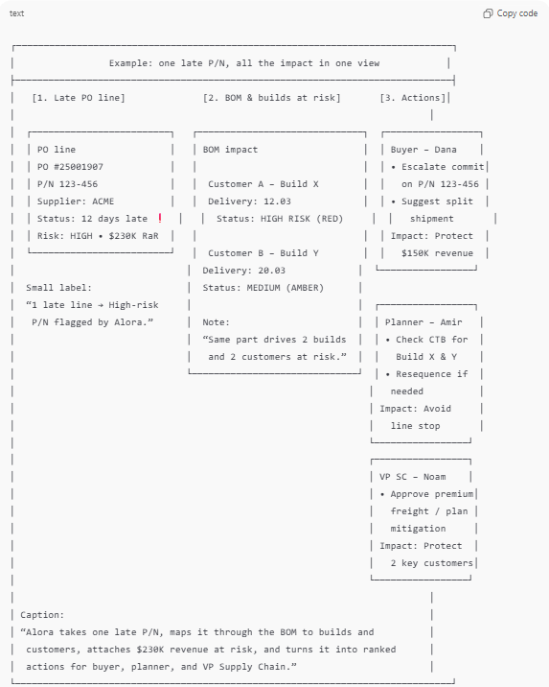
SECTION 1 – Event → Impact → Action (+ diagram)

Title
From any supply-chain event to clear impact and action
Paragraph
Alora ingests ERP, email, and BOM signals and runs an AI engine that scores every P/N.
Whether it’s a delay, EOL notice, tariff change, or quality issue, Alora shows which builds and customers are affected, how much is at risk, and who on your team owns the next move.

Line above the diagram
The diagram below is one example: a single event on a part, mapped through the BOM to builds, customers, and a ranked list of actions by role.
Caption under the diagram
Any part-level event → visible impact → ranked actions across your supply chain.

SECTION 2 – Who Alora is built for
Title
Who Alora is built for
Intro
Alora is built for complex, BOM-driven hardware manufacturers where a single part can put a whole build at risk.
Industries
- Medical devices – regulated, multi-discipline assemblies where build readiness and traceability are critical.
- Robotics & automation – multi-level BOMs, long-lead motion and control components, tightly sequenced builds.
- Industrial equipment & machinery – engineer-to-order, configurable BOMs, high-value parts, frequent ECOs.
- Electronics & systems – many suppliers, global lead times, and design/component changes that ripple through the BOM.

SECTION 3 – Measurable Impact (KPIs)
Title
Measurable impact
Subtitle
Real results from companies that transformed their supply chain operations with Alora.
Card 1
10× Faster
Decision Making
From weeks to same-day responses.
Card 2
5% Reduction
in Revenue Risk
Act before delays hit production.
Card 3
50% Less
Manual Work
Automated follow-ups and tracking.
Card 4
80% Fewer
Blocked POs
Early confirmations + discrepancy flags.

SECTION 4 – Features / Products
Title
What Alora does for you
Intro
All tools are powered by the same AI risk engine that turns supply-chain events into ranked P/N risk and next moves.
We start with three core modules and are continuously adding new workflows on top of the same engine.

Feature 1 – PO Risk & Tracking
Title
PO Risk & Tracking
One-liner
Turn open POs into a ranked TODO list, not a static report.
Bullets
- See all PO lines ordered by risk and business impact
- Understand which builds and customers each line affects
- Get suggested next moves for risky lines (follow-up, escalate, re-confirm, split)

Feature 2 – CTB & Build Readiness
Title
CTB & Build Readiness
One-liner
Know if you can really build — before the line is exposed.
Bullets
- Connect part availability and risk to upcoming builds and projects
- Highlight shortages and bottlenecks at the BOM level
- Show which orders and customers are at risk if nothing changes

Feature 3 – Vendor Behavior & Scoring
Title
Vendor Behavior & Scoring
One-liner
See how suppliers actually behave, not just what’s written on the PO.
Bullets
- Track real lead times vs. quoted, confirmation patterns, and slips
- Score suppliers at the part level based on behavior and risk
- Feed vendor scores into prioritization so risky suppliers surface first

SECTION 5 – Security & Trust
Title
Security you can build on
Text
Alora works with sensitive BOM, PO, and supplier data, so security is built into the product.
We follow industry best practices for data protection, access control, and monitoring.
Your data stays your own and is never pooled or shared across customers.

SECTION 6 – The team
Title
The team behind Alora
Text
Alora is built by people who have lived both the factory floor and the data stack:
supply-chain and operations leaders from complex hardware companies,
ERP and process experts who implemented systems like SAP and Priority,
and AI builders who know how to turn messy ERP, email, and BOM data into ranked, actionable decisions.

SECTION 7 – Final CTA
Title
See Alora on your own data
Text
We usually start with a focused look at your open POs and upcoming builds — enough to show impact without heavy IT work.
Button
Book a demo

